Young Carer Emergency Plan 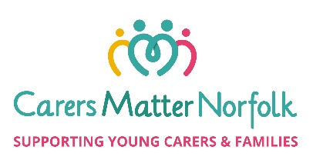
Being a young carer can be difficult at the best of times, but it can be extra stressful if something unexpected happens, either to yourself or the person you are caring for. Planning ahead can help you manage these changes by being prepared, knowing what to do and who to ask for help and support.

About me and my family:
My name is
My age
I live at
I care for
My caring role involves

Other people who live with us are
The best contact number for me is

Things that might happen to me:
If I am unwell and need someone to help me I will…

If I am unwell and need someone to help the person I am caring for, I will…

If I am stuck at school/college and I can’t get home I will…

If my situation suddenly gets worse and I am struggling to attend school/college and/or keep up with my studies, I will…

Things that might happen to the person I am caring for:
If someone else also providing care is ill or doesn’t arrive and I am left alone to care, I will...
If the person I care for becomes unwell or has a health emergency, I will…

If the person I care for needs to go to hospital and I am on my own at home, I will…

Things that might happen at home:
If there is an emergency at home e.g. flood, fire, power cut, gas leak, I will…

If I get locked out of the house, I will…

If there isn’t enough money for food & bills, I will…

My Emergency Contacts are:
Name | Number

Checklist:
Have you got your Emergency Contacts’ numbers stored on your phone?

Do your Emergency Contacts know they are on this Emergency plan and what they need to do?

Is there a Care Plan for the person you are caring for, and is it easy to find?

Date this Emergency Plan was completed:

